Digital Fruit Sclerometer Manual

Thanks for purchasing Digital Fruit Sclerometer:
The Digital Fruit Sclerometer has advantages of high precision,easy operation and carry. It can be used with a special test stand to increase measurement accuracy.
(PS:Scientific use of the measurement range is 10%-100% of full range,suggest measurement department do not to test below 1% of full range.)
One,Characteristics:
1.Digital display,easy reading,high precision;
2.Light weight,small size,easy to carry;
3.Standard fruit hardness unit display:kgf/cm²
4.The battery has over-load protection in case of short circuit and leakage of electricity .It also can tell you when the battery is running low.It adopt the 3.7V lithium battery and auto shut off if no operation in 10 minutes.
5.Two test mode:Peak hold and Real-time;
Two,Main technical parameters:
Model | GY-15 |  | GY-30
Measurement Range | 0.2～15 kgf/cm² (×10⁵ Pa) |  | 0.4～30kgf/cm² (×10⁵ Pa)
Load scale value | 0.01kgf/cm²
Precision | ±1%
Pressure needle diameter | Φ11.1mm | Φ7.9mm
Depth of pressure needle | 10mm
Power | 3.7V lithium battery
Charging time | 4~6 hours
Continuous usage time of battery | About 10 hours
Battery life | ≥300times
Charger | Input：AC 220V 50/60HZ Output：DC 5V 1000mA
Stability | Temperature drift：0.2uV/℃（0-60℃）  Zero temperature drift：≤ 0.1%/8 hour/FS
Work temperature | 5℃～35℃
Transport temperature | 0℃～60℃
Relative humidity | 15％～80％RH
Work conditions | No focus ,Non-corrosive in surroundings
Net weight | About 260g
Size | 160mm×71mm×35mm

.1.

Three,Configuration:

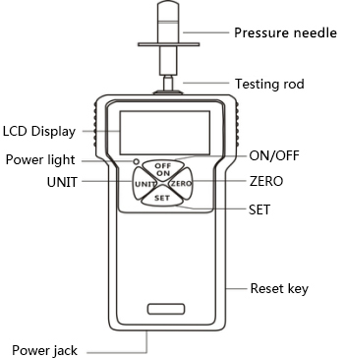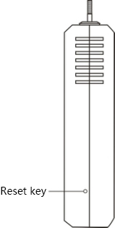

.2.
Ten:Customer service considerations(confirmation project before repairing the push pull force gauge)

Power | Symptom | Reason or phenomenon | Treatment
Power | No display when shut up | No power | Charge again
Test value | Value inaccurate | Large error | Return to the factory for calibration
Other | Died unexpectedly | No action press any keys | Press the reset button with a needle

Eleven: Appendix of the instrument
1 | Digital Fruit Sclerometer | 1 set
2 | Pressure needle（∅11.1mm）match with 15kgf/cm² | 1 set
3 | Pressure needle（∅7.9mm）match with 30kgf/cm2 | 1 set
4 | Manual | 1 piece
5 | Certificate and warranty card | 1 piece
6 | Certificate of inspection | 1 piece
7 | Charger(5V) | 1 piece
8 | Desiccant | 1 pack
9 | M6 screw | 1 set
10 | M4*6 screw | 4 sets
11 | M4*8 screw | 4 sets

.7.
2.Choose pressure needle,install it on the Digital Fruit Sclerometer.(As picture three shows)
3.Before testing:Peel the fruit about 1cm².
During testing:Align the center of fruit and Press needle vertically,the result will be more accurate.(As picture three shows)
4.Start to test:Press “ON/OFF” key to turn on the sclerometer,wait 1-2 seconds to enter the measuring interface(Press “ZERO” key if the value is not zero).Press the Handle,make the Press needle into the flesh until arrive at Scale Mark.The value shows on the Digital Fruit Sclerometer is the hardness of the fruit.(As picture four shows)
5.After testing:Remove the Digital Fruit Sclerometer and Pressure needle,clean all the items and put them back into the box for the next using.
Nine: Attention
- Notes:
- When the power is running low ,it need to charge 4~6 hours can be normal using.
- Any error operation may damage the instrument or cause serious accident.This manual indicates important matters about how to prevent accidents and the usage of instrument,please read this instructions carefully before using,keep it securely in preparation for reading again.
- Warning:
a.When in a destructive test,please wear protective masks and gloves to prevent splashes hurt you.
b.Do not use damaged or seriously bent pressure needle.
c.Do not use the Digital Fruit Sclerometer exceed the maximum load,or it will damage the sensor even cause the accident.
d.When the test value exceed the 100% full scale,the Digital Fruit Sclerometer will buzzing all the time,please reduce the load immediately or release the load.
e.To solve crash,please insert a needle into the “RSET” hole which is on the right of the sclerometer to turn off the instrument.
- Safety Precaution:
- Please use the matched charged,or it will cause circuit failure even a fire.
- Do not use power that exceed the rated voltage of charger,or it will cause electric shock even a fire.
- Do not unplug or insert charger with wet hands,in case cause the electric shock.
- Do no unplug charger by pulling line directly,in case the line is broken and cause electric shock.
- Please clean the instrument with soft cloth,put the cloth into the cleaner water,wring the cloth out and then clean dust and dirt(Attention:do not use the highly volatile chemical to clean the instrument,such as propellant,thinner,alcohol).
- Do not operate the instrument in the following environments:
Humid environment Dust environment
The place of using oil and chemicals Epicentre surroundings
g.Please use and store instrument in required temperature and humidity,or it will cause failure.
h.Do not dismantle,repair or restructured the instrument by yourself,it will cause permanent damage.
- Other safety precaution not mention.

.6.
Four,Button function
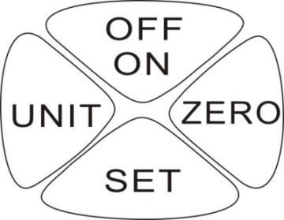
-OFF/ON(start up ,shut down key):When press this key,turn on the power,appear measuring interface.Press this key again can shut down gauge.
-ZERO(zero key):The testing value on the screen can be zero when click this key.
-SET(switch mode key):When press this key,enter the ”Peak” mode.Press “SET“key for 4-5 seconds after starting up,and then loosen,can enter into the setting interface.
-UNIT(unit key)Press “UNIT“key for 4-5 seconds,the digital value inverted display.

Five,Screen display

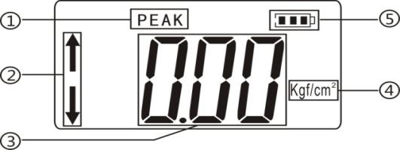
- Peak mode: After turn on,enter into the measuring interface,click “SET” button can enter into the peak mode directly,record the Max. value during measuring.
- Push pull force shows:do not move the gauge,the above arrow shows the pull force,the below arrow shows the push force.
- Measuring force value display.
- Standard fruit hardness unit display:Kgf/cm².
- Power display.
Six,Boot display
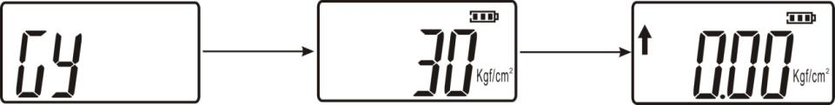
Seven, Function operation
Press “SET”key for 4-5 seconds after starting up,and then loosen,can enter into the setting interface, display”HIDT”,and then continuous press “UNIT” key will appear other settings items :
”LODT” ,”L.SET”,“OFFT”,“G.SET” ,“BAC.S” ,“R.SET”
show as the picture below:

.3.
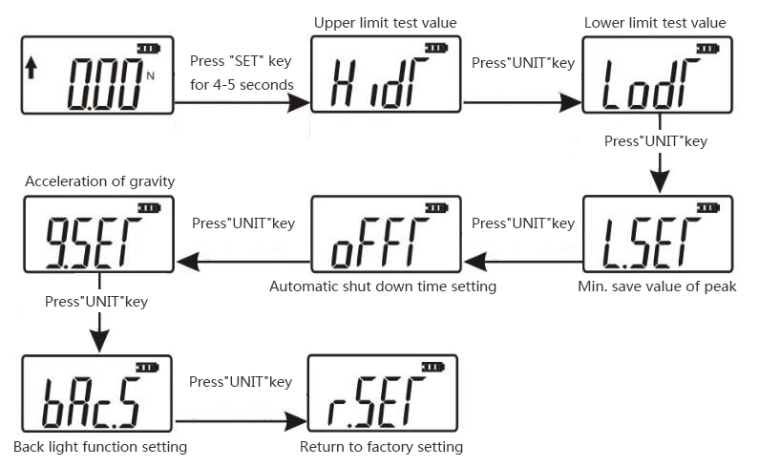

 (HIDT) upper limit testing value setting:to set upper limit test value,the default state of the upper limit value is 100% of full range ,above upper limit is out of range and the instrument will buzzing.If you want to set the upper limit value again,please press “unit” key and “zero” key .Press “SET” key to save and return to setting interface automatically.
Show as the picture below:
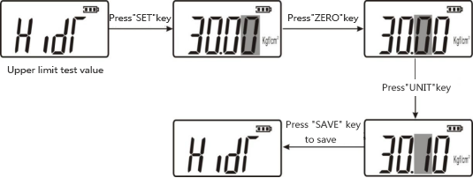
(LODT) Lower limit testing value setting:to set lower limit test value ,its default state is zero.Below lower limit is out of range,the instrument will buzzing.If you want to set the lower limit value again,press “UNIT” key and “ZERO” key for setting.The same as previous step.Press “SET” key to save and return to setting interface automatically.
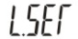(L.SET) Min. save value of peak :the minimum peak value saved, when in peak mode,when the current value is smaller than it,the value will not be saved.
(OFFT) Automatic shut down time setting:when in this mode,please press “UNIT” key and “ZERO” key for setting,it can set auto shut down from 1 to 9999 minutes,it can also set “00” for not auto shut down. If you select not auto shut down,press “SET’ key to complete.Then return to setting interface.The default setting of instrument is 10 minutes.

.4.
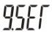(G.SET) Acceleration of gravity setting:the users can set acceleration of gravity according to their area.The default value is 9.800.
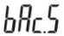(bAC.S) Back light function setting:when in this mode please press “UNIT” key for optional,if you select “yes” means open back light function,if you select”no” means close back light function, then press “SET” key for saving and return to setting interface.
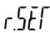(R.SET)Return to factory setting,when in this mode,press “SET” key will return to factory setting,the instrument will show down.Turn on the instrument again for using.
Eight, Testing
1.Fix the Digital Fruit Sclerometer on the Test Stand(Test Stand need to be bought separately:
A.Install the Digital Fruit Sclerometer on the mounting plate using four M4*6 screws.
B.Loosen “Adjusting handle 1”,slide it down until the upper end of “Part 2”(Two M3 holes are exposed at the upper end of “Mounting plate 3”).Use two M3*6 cross recessed pan head screws to pass through the two M3 hole at the upper end of “Mounting plate”,fix the adapter plate and the "Mounting plate 3" together.Finally,loosen “Adjusting handle 1”,restore the position,and then tighten the "adjust the handle 1" to fix it.(As picture one shows)
C.Turn the “Handle 4” clockwise (Two M3 holes are exposed at the lower end of “Mounting plate 3”).Use two M3*6 cross recessed pan head screws to pass through the two M3 hole at the lower end of “Mounting plate”,fix the adapter plate and the "Mounting plate 3" together.(As picture two shows)
D.Follow as two operations above,tighten four screws.


