Instruction Manual for Replaceable Head Digital Torque Wrench
- Overview
1.1 Main purpose and applicable scope
The replaceable digital display torque wrench is different from the general torque wrench. Its own ratchet head can be replaced with an open head, a plum blossom head, a movable open head and other plug-ins. It has powerful operation functions, including torque setting; unit setting; mode setting; value storage; value clearing; value output and user correction function with easy to operate, the operator's requirements are reduced by the installation of a digital display.It is applicable to bolt fastening and control in the automotive industry, machinery industry, etc.
1.2 Features of functions
1.2.1 Replaceable head
1.2.2 Digital Torque Reading
1.2.3 Accuracy with ±2% clockwise, ±2.5% counterclockwise (20~100% in maximum operating range)
1.2.4 It can be operated by both clockwise and counterclockwise
1.2.5 Peak maintain and real-time mode
1.2.6 Buzzer and LED indication (when the preset torque value is reached)
1.2.7 Four engineering units (ft.lb、in.lb、N.m、kgf.cm）
1.2.8 100 sets stored record values
1.2.9 Communication function
1.2.10 Automatic shut-down after 5 minutes
1.3 产品型号选型/Product’s model and selection
型号/Model:
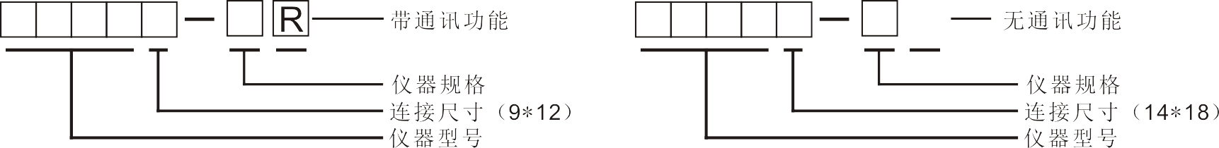
Without communication function
Instrument specification
Connection size (14*18)
Instrument model

With communication function
Instrument specification
Connection size (9*12)
Instrument model

①Max. accuracy
Accuracy
±2%-clockwise/±2.5%-counterclockwise
②：Whether has communication function or not
Communication and transmission functions
None | None
R | Yes
- Functions and names of each component
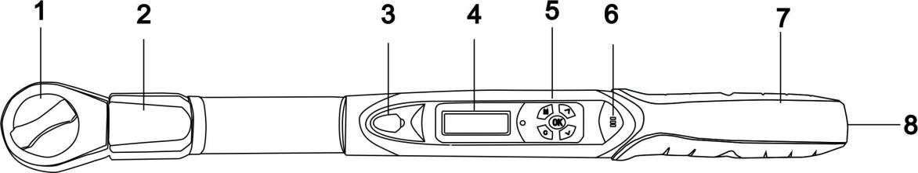
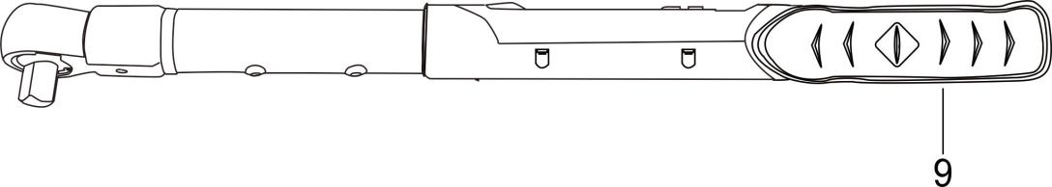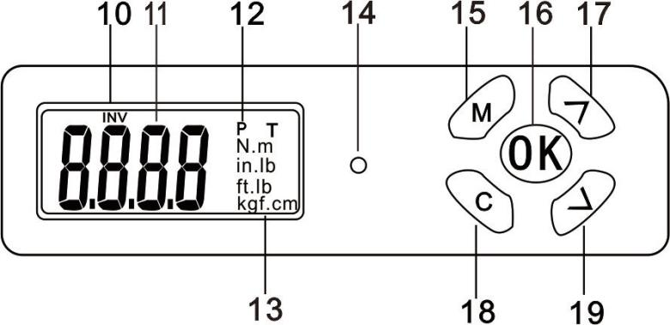
1、Pre-installed ratchet head (replaceable) 2、Sensor
3、Communication hole 4、LCD screen
5、Key 6、Buzzer
7、Battery box 8、Battery box
9、Handle 10、Test direction（no display：FOR；INV：REV）
11、Torque value display 12、P（peak mode）、T（real-time mode）
13、Units（N.m、in.lb、ft.lb、kgf.cm） 14、LED indicator
15、Setting menu/Selection keys 16、Enter/Save key
17、Up selection key 18、Power/Cancel/Clear keys
19、Down selection key

3. Product technical specification
Note: (AWGC-030A/B can choose two ratchet head configurations, A- means 1/4, B- means 3/8, factory default is 1/4 configuration)

Model | Without communication | 010 | 030 | 030 | 060 | 085 | 135 |  | 135 | 200 | 340
Model | With communication | 010R | 030R | 030R | 060R | 085R | 135R |  | 135R | 200R | 340R
Minimum scale value |  | 0.01 |  |  |  |  |  |  | 0.1
Maximum operating range  （N.m） |  | 10N.m/7.37ft.lb/88.50in.lb/101.97kgf.  cm | 30N.m/22.12ft.lb/265.5in.lb/305.91kgf.  cm | 30N.m/22.12ft.lb/265.5in.lb/305.91kgf.  cm | 60N.m/44.25ft.lb/531.04in.lb/611.82kgf.  cm | 85N.m/62.69ft.lb/752.31in.lb/866.75kgf.cm | 135N.m/99.57ft.lb/1195in.lb/1376.61kgf.cm |  | 135N.m/99.57ft.lb/1195in.lb/1376.61kgf.cm | 200N.m/147.5ft.lb/1770in.lb/2039.43kgf.  cm | 340N.m/250ft.lb/3009in.lb/3467.03kgf.  cm
Joints  (inches) |  | 9*12 |  |  |  |  |  | 14*18
Buzzer setting range (Nm) |  | 0.5~10 | 1.5~30 | 1.5~30 | 3~60 | 4.25~85 | 6.75~135 |  | 6.75~135 | 10~200 | 17~340
Length (mm) |  | 390 |  | 420 |  |  |  |  | 535 |  | 655
Accuracy |  | Clockwise: ±2%  Counterclockwise: ± 2.5%
Data storage capacity |  | 100
Operating mode |  | Peak hold (p) / real time mode (t)
Unit |  | N.m、in.lb、ft.lb、kgf.cm
Ratchet head form |  | Pre-installed ratchet head, can be replaced with plugs such as open head, plum head, movable open head
Number of key |  | 5
Battery |  | 2 1.5v 5 batteries
Operating temperature |  | -10℃~60℃
Storage temperature |  | -20℃~70℃
Humidity |  | No condensation can reach 90%
Drop test height |  | 1 meter
Vibration test conditions*2 |  | 10G
Life test*3 |  | 10,000 times
*：Please refer to the notes after the form
Note:
*1.The accuracy guarantee range is 20% to 100% of the maximum operating value, and the last digit is ±1, which can be omitted. Torque accuracy is a normal value.The correction accuracy is the correction point with the middle groove of the five grooves on the handle.To ensure accuracy, it is recommended to calibrate once a year.
*2. Life test includes horizontal test and vertical test.
*3.“One time” means that the wrench is applied from 0N.m to the maximum operating set value of the wrench, and then returns to 0N.m.

4. Precautions before using the wrench
4.1 Put the battery
4.1.1 Remove the battery cover.
4.1.2 Insert two 5# batteries into the battery compartment, please pay attention to the positive and negative directions.
4.1.3 Close the battery cover and rotate the battery cover to the position as shown in the following figure.

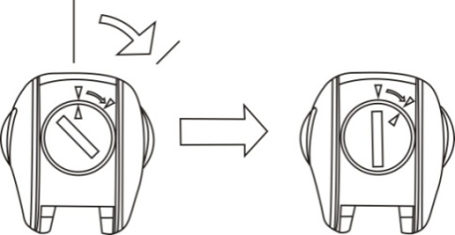
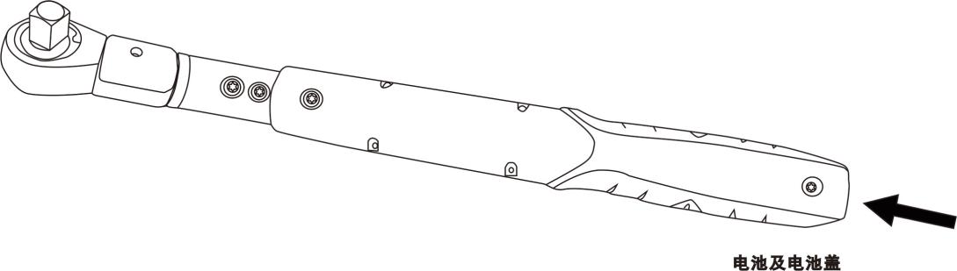
Battery and battery cover

4.2 Turn on power and reset
4.2.1 Press “C” key to turn on wrench power supply
4.2.2 After the power is turned on, press the “C” key to reset the wrench before use.

Note：
- If the wrench has applied an external force to the wrench before turning on the power, an offset value will be displayed on the screen after the power/reset is turned on.
- "Nm" and "T" are loaded from the EEPROM.Once the user changes the unit or mode, the EEPROM will always be present.
4.3 Wake up the wrench while sleeping
4.3.1 The wrench is used for power saving, such as no operation.It will enter sleep mode after about 5 minutes.Press the “C” button to wake up the wrench
4.4 Low voltage protection
4.4.1 If the system detects that the battery voltage is lower than 2.2V, the wrench will cut off the power; when the wrench voltage is lower than 2.2V, the wrench will automatically shut down.
5 Settings
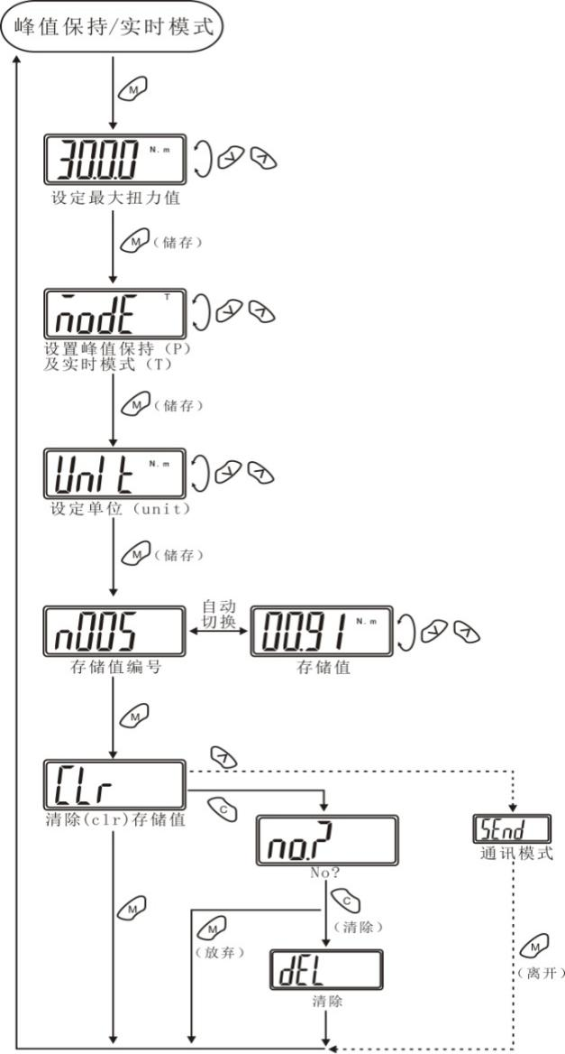
Clear (clr) saved value Communication mode

(Discard) (Clear) (Leave)

(Clear)
Saved value No. Saved value
Set unit (unit)
(Save)

(Save)
Set peak maintenance (P) and real-time mode (T)
(Save)
Max. setting torque value
Peak maintenance/Real-time mode
Note:
1. If there is no data in the memory, the screen displays “n000” and then automatically switches to the stored value “0000”.
2 The communication mode is used to upload records to the computer.

6. Real-time mode
Start
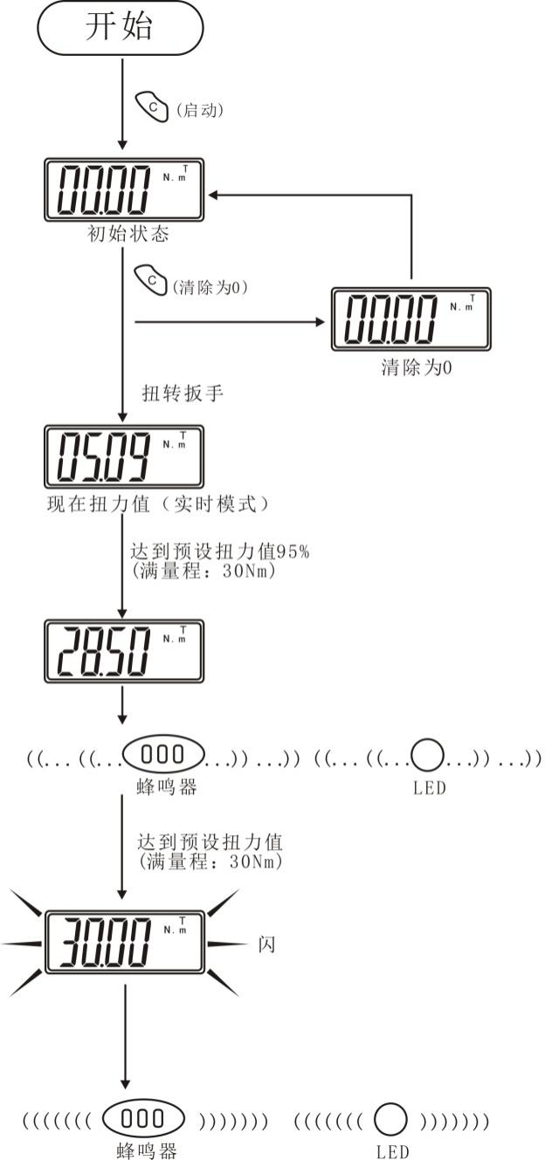
Flash
Reached preset torque value
(Full range: 30Nm)
Buzzer
Current torque value (real-time mode)
Reached preset torque value 95%
(Full range: 30Nm)
Torque wrench
(Clear to zero)
(Clear to zero)
Initial status
(Start)
Buzzer

7. Peak maintenance mode
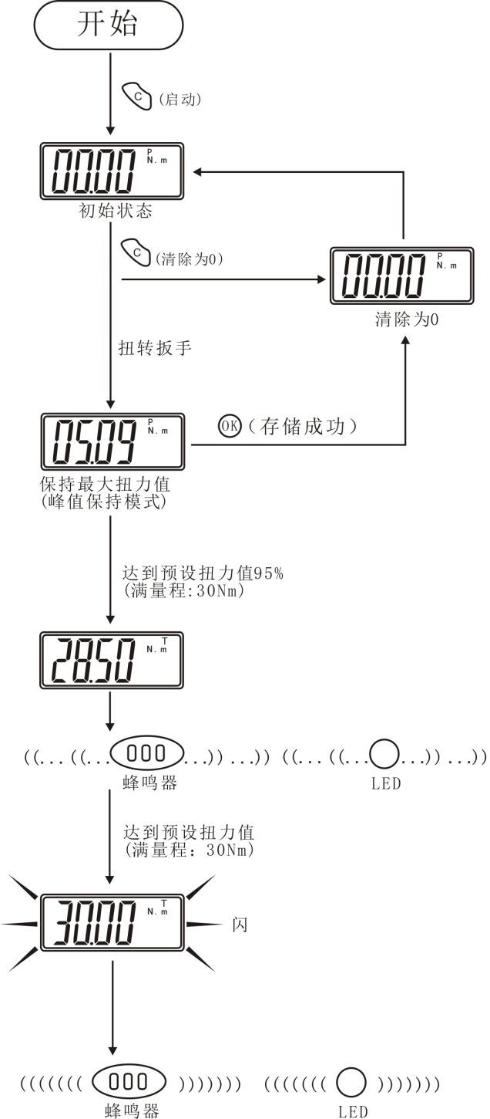
Buzzer
Reached preset torque value
(Full range: 30Nm)

Buzzer
Reached preset torque value 95%
(Full range: 30Nm)

Maintain max. torque value
(Peak maintenance mode)
Successfully saved
Torque wrench
(Clear to zero)
(Clear to zero)
Initial status
(Start)
Start

8. Communication functions
8.1 Connecting the communication line
8.1.1 After turning off the power of the wrench, use the attached communication cable to connect the computer communication hole and the wrench.
8.2 Uploading stored values
8.2.1 Make sure that the PC and the wrench are connected.
8.2.2 Press the wrench operating mode to “”.(Refer to the "Settings" section)
8.2.3 Start uploading software on the PC.
8.2.4 In uploading the software, firstly select the correct Com No and click “Port Open” to open the port.
8.2.5 Next, click the upload button to transfer the stored value to PC.
8.2.6 Finally, click on “Export” and the system will automatically open the uploaded data in Excel format.
8.2.7 Select the appropriate storage path to save the data table you uploaded.

- Maintenance and storage
9.1 Note: In order to maintain good accuracy, it is recommended to re-calibrate approximately once a year.
9.2 Over-torque may cause damage or loss of accuracy (exceeds 105% of the maximum torque range).
9.3 Do not shake the wrench dramatically or drop the wrench to the ground.
9.4 Do not use the wrench as a hammer.
9.5 Do not place the wrench in a place with high temperature, high humidity or direct sunlight.
9.6 Do not use the wrench near the water.
9.7 If the wrench is accidentally wet , dry it with a dry towel immediately.Salt in the sea can damage the wrench.
9.8 Do not use organic solvents to clean the wrench, such as alcohol or paint thinner.
9.9 Do not place the wrench close to a magnetic object.
9.10 Do not place the wrench in a place with a lot of dust or sand, which can cause serious damage to the wrench.
9.11 Do not press the LCD screen hard.

10. Disposal of battery
10.1 If you do not use the torque wrench for a long time, please take out the battery.
10.2 When you need to travel long distances or in a cold area, please prepare a spare battery.
10.3 Do not mix batteries of different brands, and do not mix old and new batteries.
10.4 Sweat, oil dirt, etc. will hinder the contact of the battery electrode. Please wipe the battery clean before putting it in the torque wrench.
10.5 Please discard the used battery at the designated recycling location.Do not put the battery in a fire.

11. Detailed table for enclosed accessories
1 | Digital torque wrench (pre-installed ratchet head) | 1 PCS
2 | Instruction manual | 1 copy
3 | Battery cover key | 1 PCS
4 | Certificate | 1 copy
5 | Warranty Card | 1 copy
6 | Inspection certificate | 1 copy
7 | Dryer | 1 pack
8 | 5# battery | 2 PCS
9 | Host computer installation CD (with communication configuration) | 1 PCS

